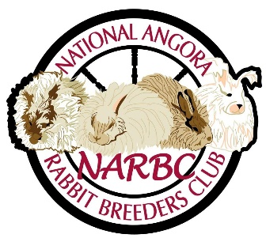
NARBC’s “Bunny Bucks” Youth Program

The new “Bunny Bucks” youth program was created to encourage our NARBC youth members to exhibit their Angoras and to accelerate our youth exhibitors' excellence. This youth program is for youth members of the National Angora Rabbit Breeders Club, Inc. that are under the age of eighteen years old with a current youth membership or part of a family membership with NARBC. To qualify for the program the member must be in good standing, have a current membership and show in open or youth ARBA and NARBC sanctioned shows to earn the “Bunny Bucks”.

Program:
- To earn “Bunny Bucks” the youth must place; Best in Show, Reserve in Show, Best of Breed or Best Opposite of Breed with a recognized variety of English, French, Giant or Satin Angora with a minimum of three exhibitors and five rabbits in the class and be sanctioned with ARBA and NARBC.
- A “Bunny Buck” show report must be provided along with a picture of the youth with the winning Angora mailed/emailed to NARBC designated representative, Robin Olson, 414 Woodside Dr., Harrisburg, NC 28075; email address narbcsweeps@gmail.com.
- When NARBC’s designated representative receives the “Bunny Bucks” show report, the picture and the official ARBA/NARBC show report the “Bunny Bucks” will be mailed/emailed to the youth.
- “Bunny Bucks” will be paid out and mailed/emailed as follows:
  - Best In Show - $5.00
  - Reserve in Show - $4.00
  - Best of Breed - $2.00
  - Best Opposite of Breed - $1.00
- “Bunny Bucks” coupons must be submitted with merchandise order from the Youth Store. Coupons must cover the cost of merchandise as well as shipping cost.
  - NARBC Logo Drawstring Bag - $12.00 + S/H
  - NARBC Logo Notebook & Pen - $15.00 + S/H
  - NARBC Logo Stainless Steel Mug - $20.00 + S/H
- If “Bunny Bucks” redeemed exceed the amount of order, the coupons will be returned with the difference in amounts to the nearest dollar.

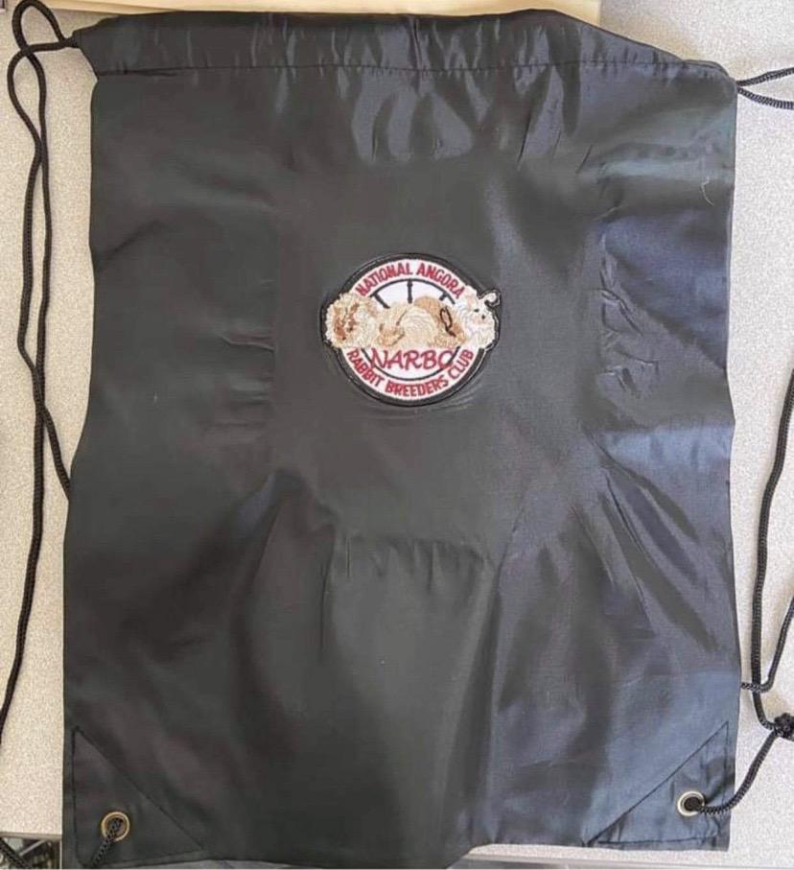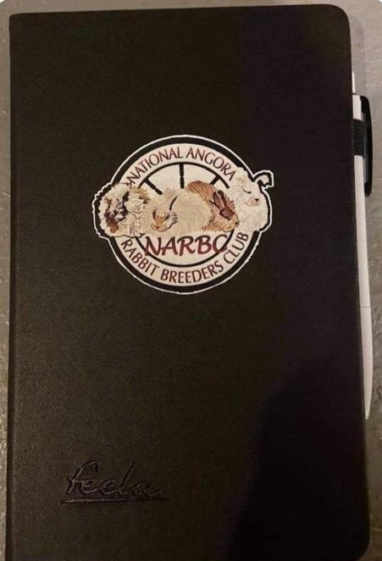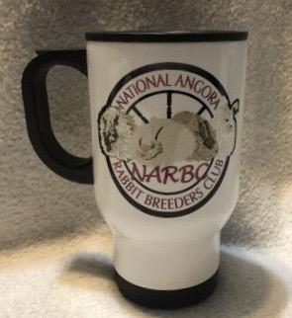
Drawstring Bag w/NARBC Logo Notebook with Pen w/NARBC Logo Stainless Steel Mug w/NARBC Logo

