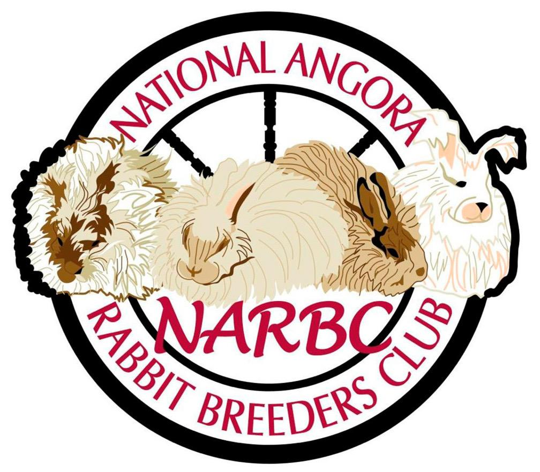
“Bunny Bucks” Report Form

Youth Name: ____________________________________________ NARBC Membership #: ___________

Address: _______________________City: ____________________State: ___________Zip: ___________

Parent/Guardian: _______________________________________________________________________

Date of Show: | Show: | Breed/Varity/Sex: | BOSB | BOB | RIS
TOTALS:
PLEASE SUBMIT THIS FORM FOR EVERY SHOW AS WELL AS A PHOTO OF THE “WINNERS” TO RECEIVE “BUNNY BUCKS”

